# **Experiment 3**

**Aim:**

To Design an ER Diagram for your project, Object Detection Solution.

**Theory:**

An entity–relationship model (or ER model) describes interrelated things of interest in a specific domain of knowledge. A basic ER model is composed of entity types (which classify the things of interest) and specifies relationships that can exist between entities (instances of those entity types).

In software engineering, an ER model is commonly formed to represent things a business needs to remember in order to perform business processes. Consequently, the ER model becomes an abstract data model, that defines a data or information structure which can be implemented in a database, typically a relational database.

**Why use ER Diagram?**

* Helps you to define terms related to entity relationship modelling.
* Provides a preview of how all your tables should connect, what fields are going to be on each table.
* Helps to describe entities, attributes, relationships.
* ER Diagrams are translatable into relational tables which allows you to build databases quickly.
* ER Diagrams can be used by database designers as a blueprint for implementing data in specific software applications.
* The database designer gains a better understanding of the information to be contained in the database with the help of ER Diagram.
* ER Diagram allows you to communicate with the logical structure of the database.

**What are the Components of ER Diagram?**

* **Entity:** A real-world thing either living or non-living that is easily recognizable and non-recognizable. It is anything in the enterprise that is to be represented in our database. It may be a physical thing or simply a fact about the enterprise or an event that happens in the real world.
* **Relationship:** Relationship is nothing but an association among two or more entities. For example – Tom works in the Chemistry department. Entities take part in relationships. We can often identify relationships with verbs or verb phrases.
* **Attribute:** It is a single-valued property of either an entity-type or a relationship-type. For example, a lecture might have attributes: time, date, duration, place, etc. An attribute is represented by an Ellipse.

**ER Diagram for the Object Detection Solution:**

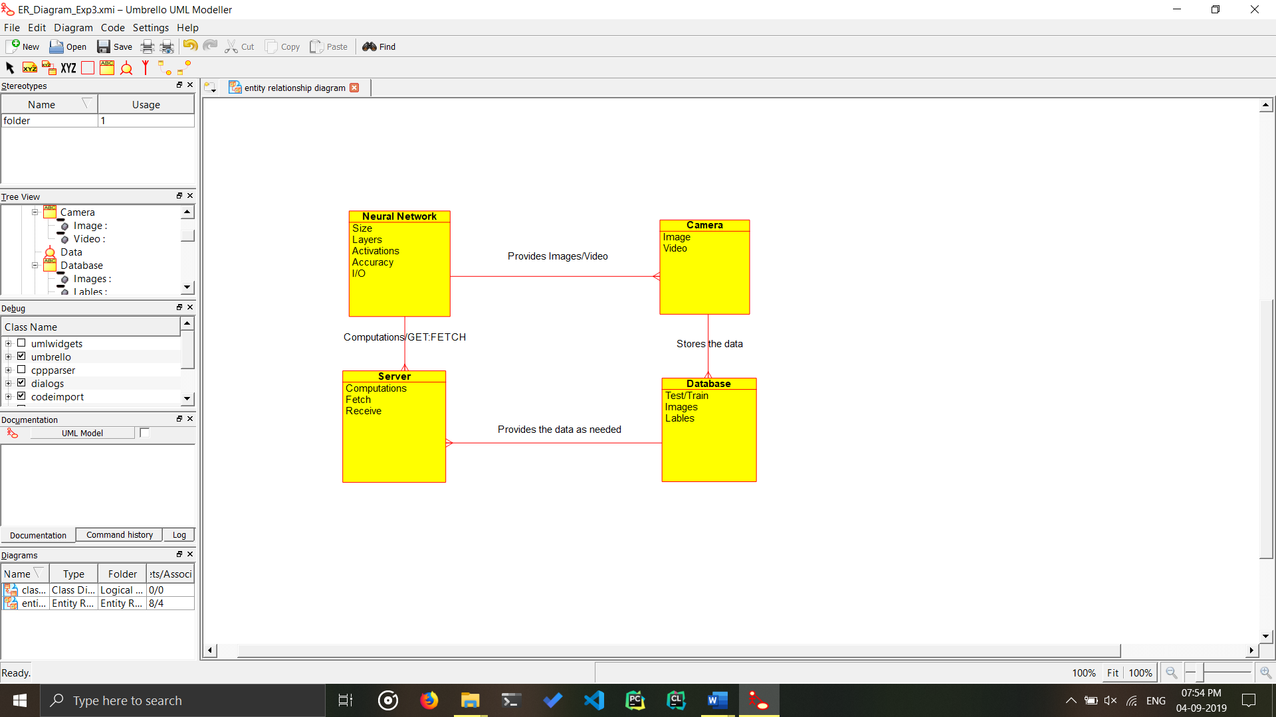

**Conclusion:**

The ER Diagram for the project has been successfully created.